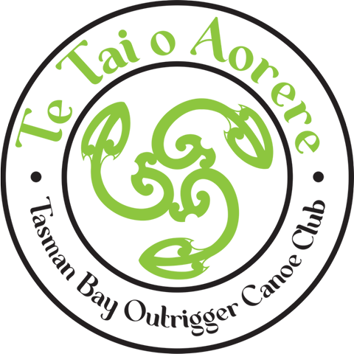
Hoe Matariki
Tahunanui Beach
Nelson
Panui#3
Kia ora kotou
This event is going to be a small intimate affair
Friday we have 2 novice crews racing 5km at 9.30am followed by our relay event starting at 10.15am. We should be all over by 12pm.
Saturday the weather is not meant to be nice so we have decided to run the Women and Mixed with the small craft in Race #1 - start time will be 8am for the small craft and 8.15am for the w6s. Registration and safety checks will be available from 7.15am Race #2 will now be the Mens event estimated to start at 10am
High tide is 05.49 Friday and 06.42 Saturday. The return from Oyster Island will be fast with the outgoing tide!
Relay course Oyster Island Course
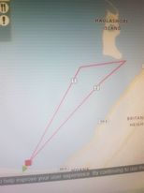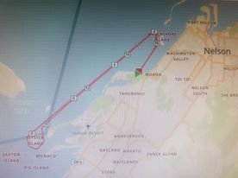
Frank Nuhaj Gardening and maintenance services will be the jet ski lead vessel and Earth Electrical and Pinkft Nelson our support boats
Thank you to our sponsors ………….
